Practical - 5
Practical Title: Registration Form with Frontend Validation and User-Friendly Error Handling

Create a student registration form with HTML5 input types and JavaScript validation for name, email, mobile number, password, confirm password, course, year, gender, and terms acceptance. Use Regular Expression for validations.

Theory
1. Are correct input types and attributes used?
Yes, correct input types and attributes are used.
- Text fields use appropriate types such as text, email, and password.
- Required fields use the required attribute for validation.
- Input fields use suitable attributes such as placeholder, name, and id.
- HTML5 validation attributes like pattern, min, max, and maxlength are used where required.
- These attributes help ensure proper data entry and form validation.
2. Are validation errors displayed near the relevant fields?
Yes, validation errors are displayed near the relevant input fields.
- Users can easily identify which field contains incorrect or missing information.
- Error messages are shown when the entered data does not match the required format.
- This makes it easier for users to correct their mistakes quickly.
- For example, invalid email or password input displays an appropriate error message near the field.
3. Is password strength checked?
Yes, password strength is checked.
- The password is validated based on the required pattern.
- It checks whether the password meets the minimum length and character requirements.
- If the password is weak or does not match the required pattern, a popup error message is displayed.
- The user must enter a valid/strong password before the login form can be submitted.
4. Is the form accessible using keyboard and screen-reader-friendly labels?
Yes, the form is accessible using the keyboard.
- Users can move between input fields and buttons using the Tab key.
- All form fields have clear labels, making them easier for screen readers to understand.
- Buttons have descriptive names such as Login, Submit, and Logout.
- The form provides error messages when incorrect or missing information is entered.
- Proper HTML form elements like <label>, <input>, and <button> improve screen-reader compatibility.
- The form does not rely only on color to communicate errors or information.

Implementation/ Output/Result

My learning codes: https://drive.google.com/file/d/1CPP3uUq3gdKZxC3pFB7iheZVU7FCImSx/view?usp=drive_link

Evidence of Work (Screenshots)
Register page:
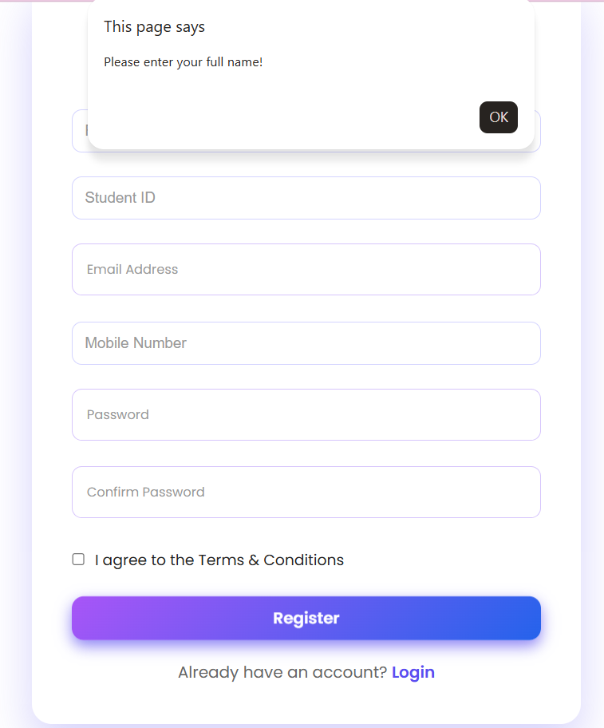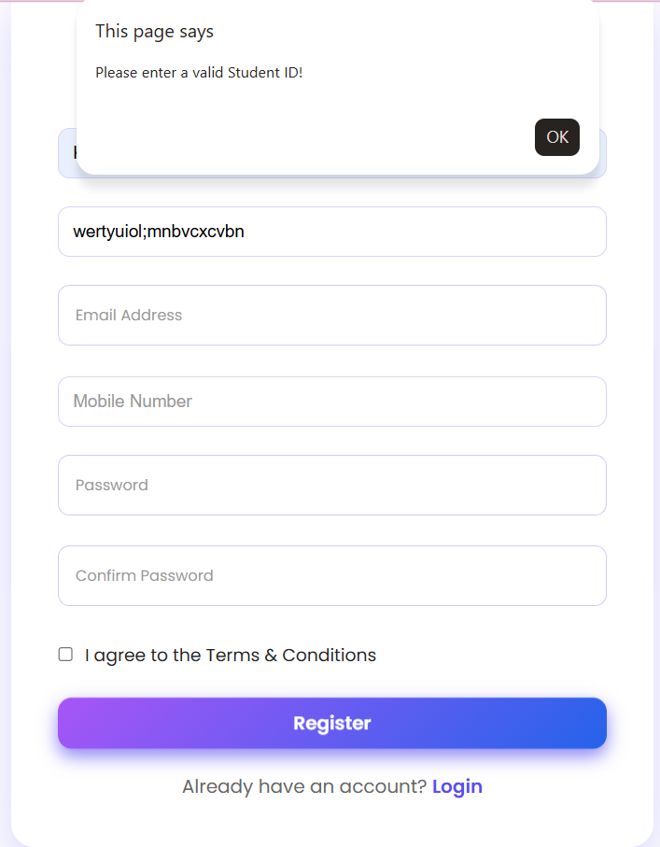
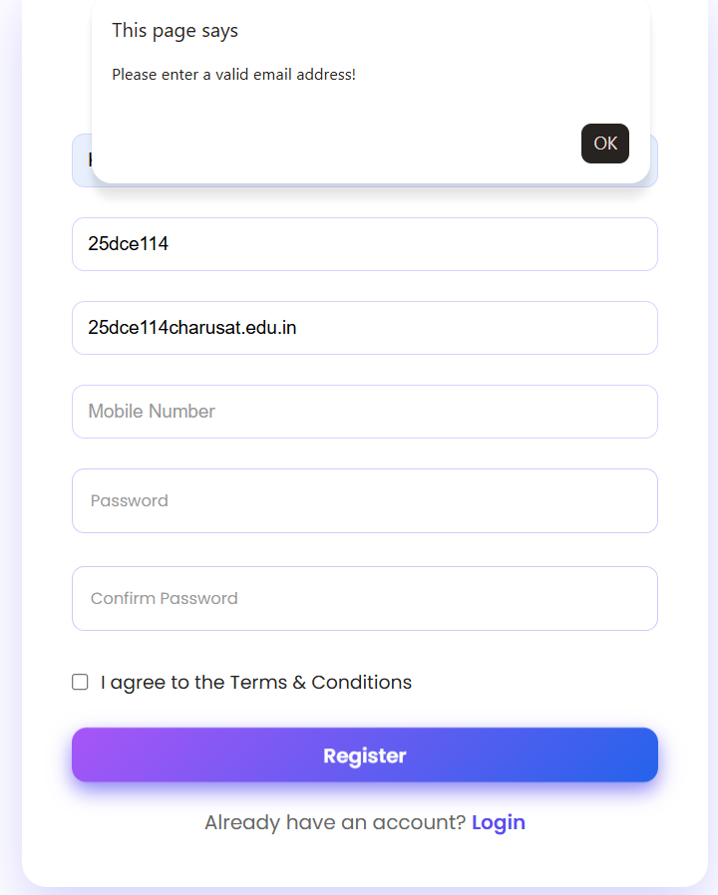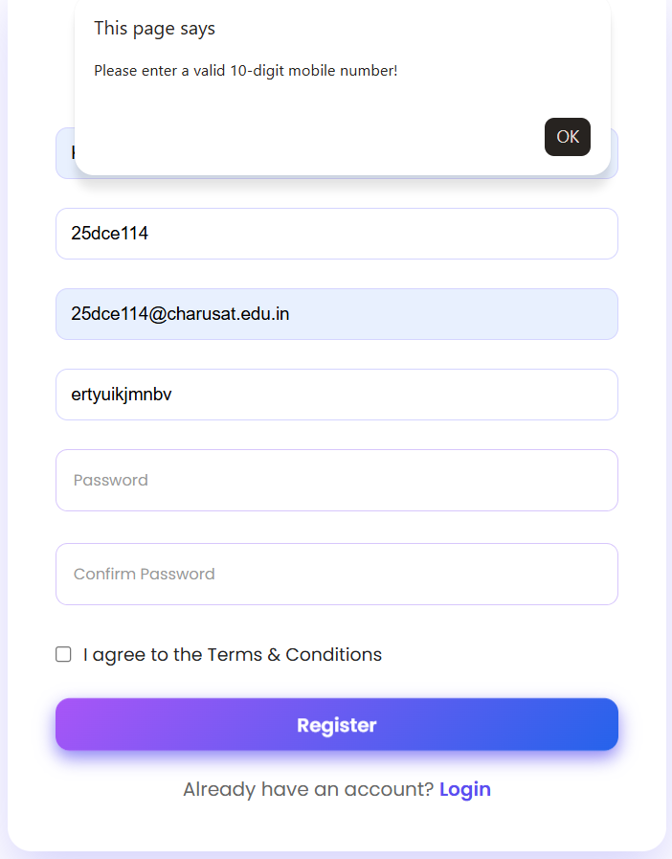

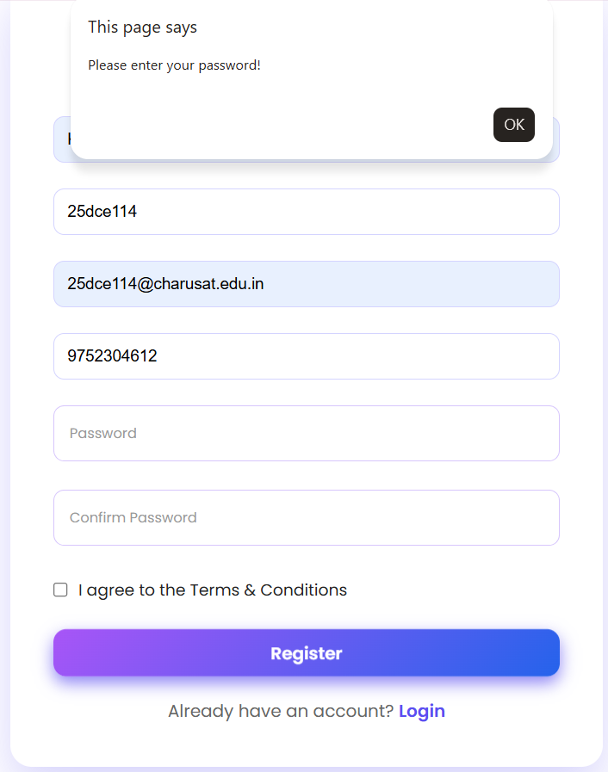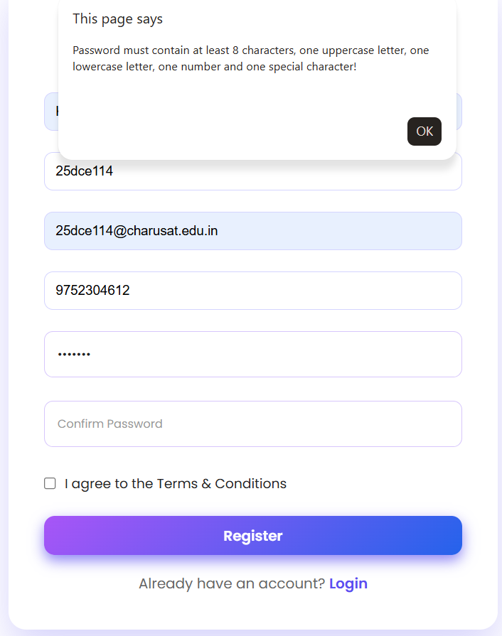
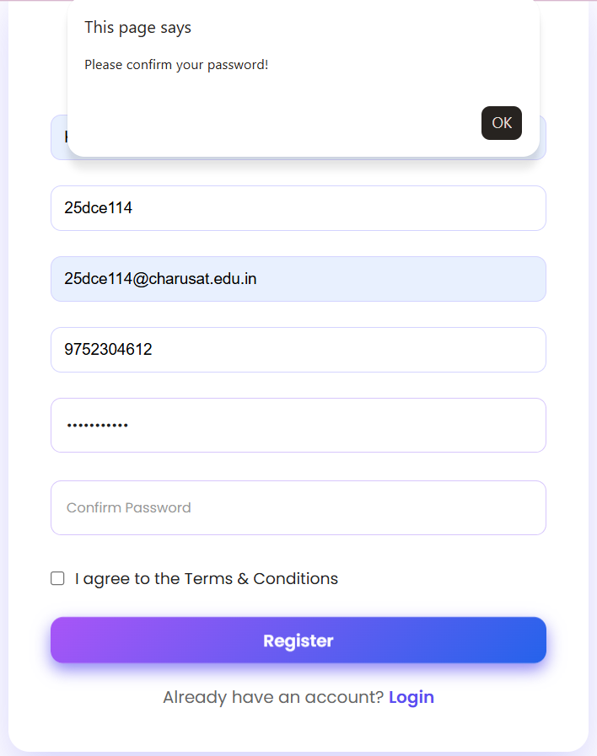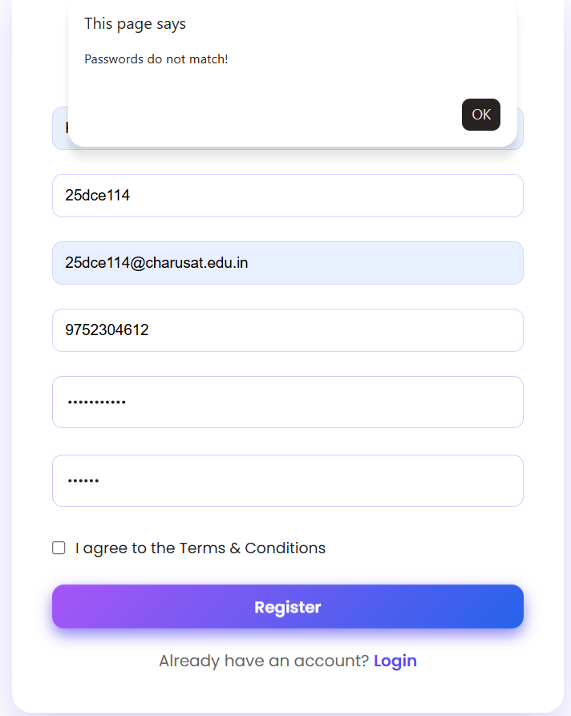

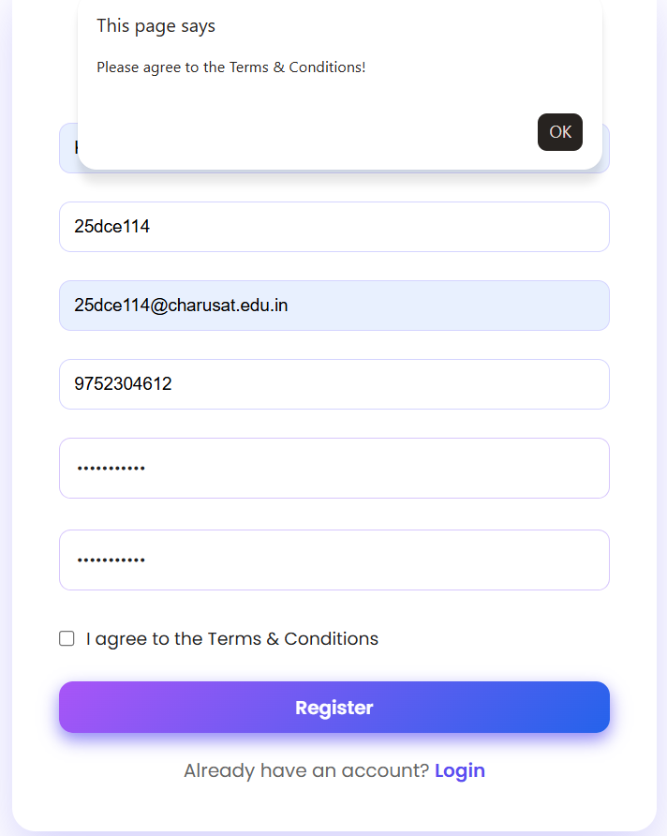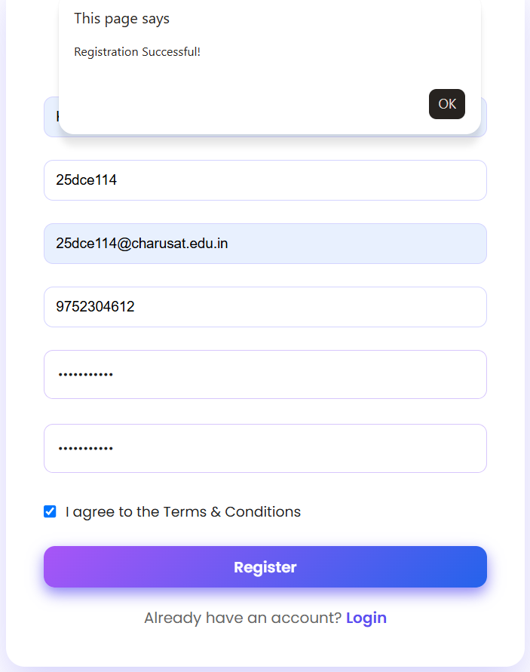
Login page:
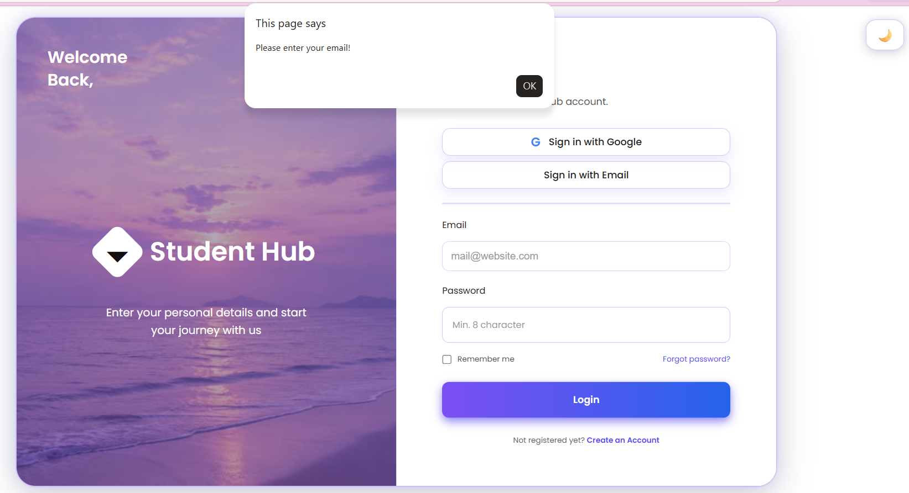
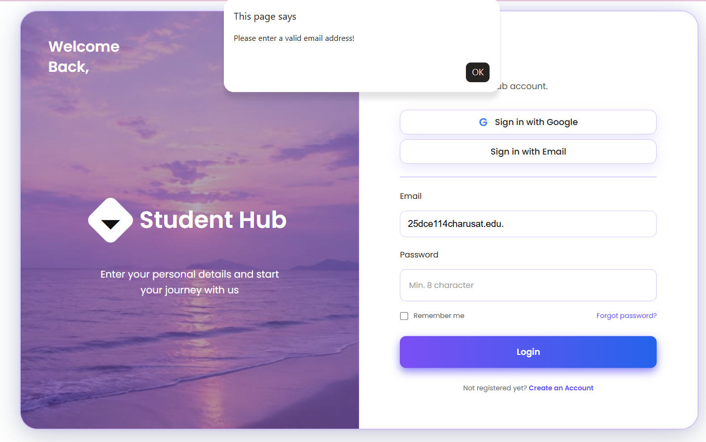
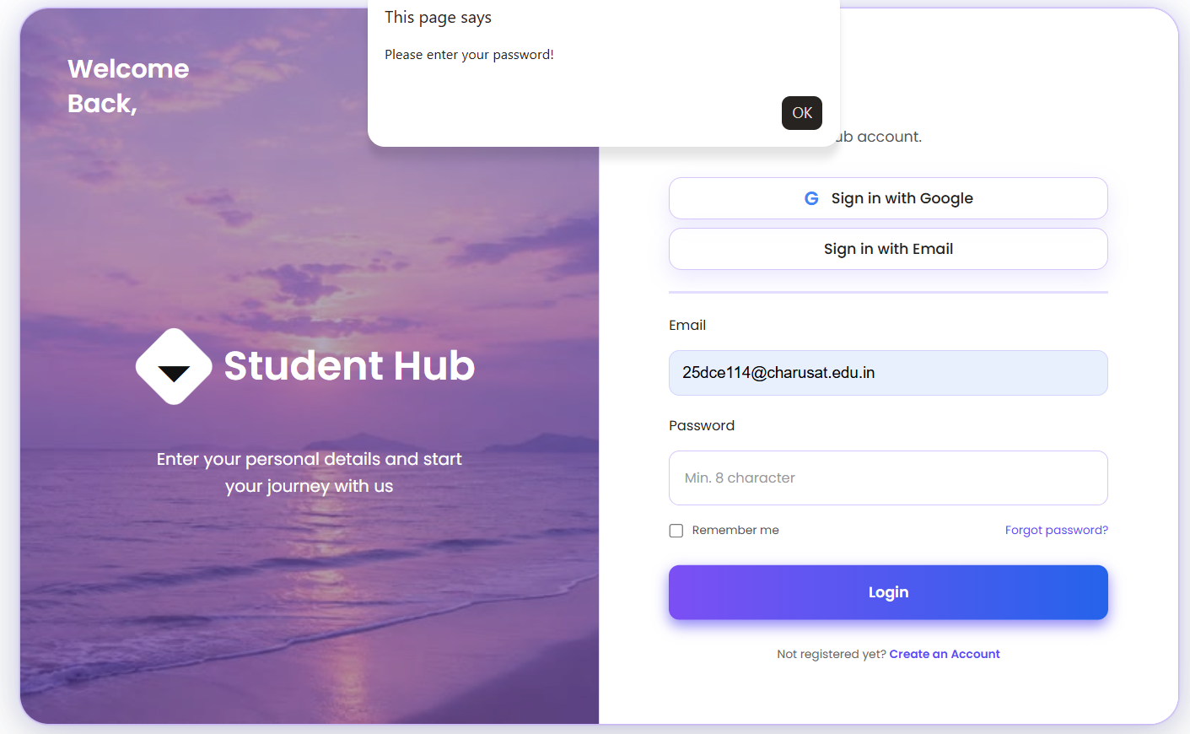
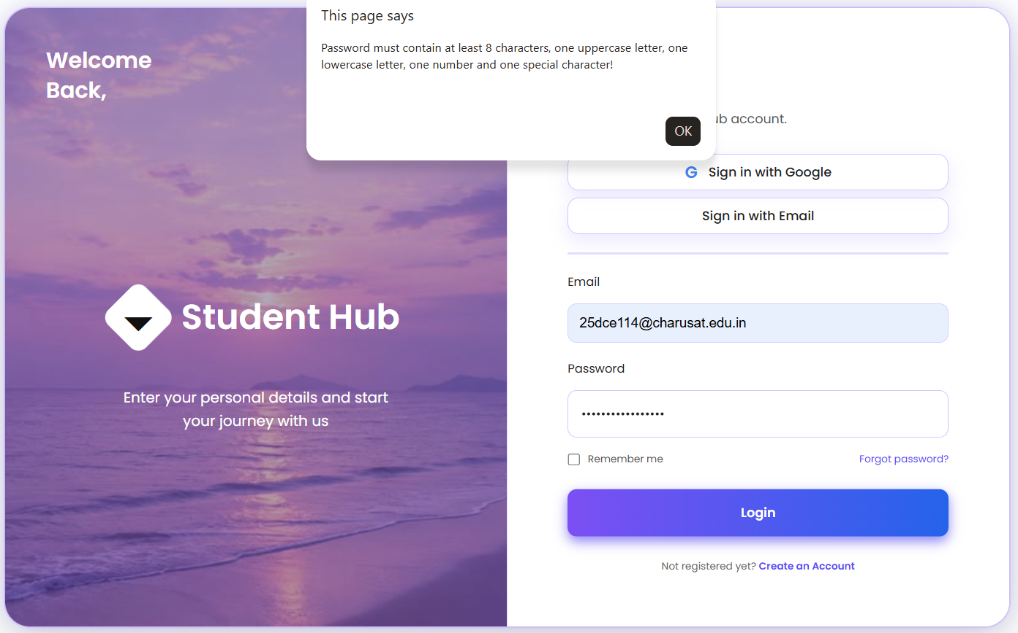
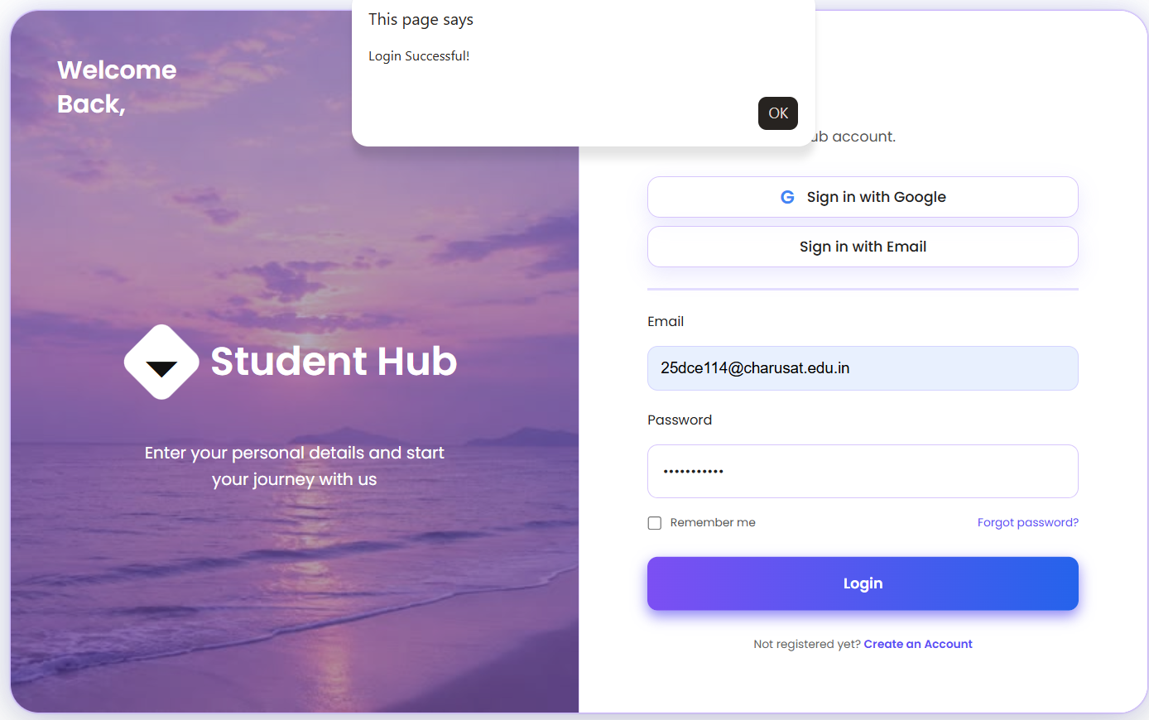

GitHub Repository Link:
Khushi-Thakor2007/Student-Hub-Portal

Challenges Faced:
I have faced the problem in inserting the pop up message with rejex.

Learning Outcomes:

I learnt basic rejex from this practical.

Faculty Remarks:

